TEMPLATE AND INSTRUCTIONS FOR AUTHORS
M. Jovašević-Stojanović (1), A. Bartoňová (2)
(1) Institute Vinca, University of Belgrade, Belgrade, Serbia, (2) NILU – Norwegian Institute for Air Research, Kjeller, Norway
mjovst@vin.bg.ac.rs
ABSTRACT
This document gives you brief instructions for preparing papers for WeBIOPATR Workshop and Conference. Use this document as a template if you are using Microsoft Word, and please use the provided styles.
INTRODUCTION
This document is a Microsoft Word template for WeBIOPATR Workshop and Conference. Please note that these instructions must be followed exactly, otherwise your paper will run the risk of being excluded from the publications.
INSTRUCTIONS FOR PAPER PREPARATION
The length of your complete paper (including text, tables, figures and references) should be at least FOUR A4 pages length (single sided).
The text of paper must be produced in black and white but figures (if required) can be produced in colour.
Page margins should be set to 3cm for the left margin and the rest set to 2.5cm.
Use font Times Roman with size 10 for the main text (style NormalWB) and size 9 for the Abstract (style AbstractBodyWB).
The title should be in uppercase BOLD, font size 10 and centered. Use style PaperTitleWB.
Authors (Initials and family name) with affiliations. Times Roman; bold; centered; font size 10 for authors, and italic, size 10 for affiliations. If there is more than one author then indicate the affiliation numerically e.g. A. N. Other (1), B. N. Other (2), etc. (1) AffiliationX, (2) Affiliation Y etc. Use style AuthorWB for authors and AffiliationWB for affiliation.
The Abstract should be no more than 150 words in font size 9, single spaced and fully justified.
The main text should be single spaced and subdivided appropriately in non-numbered sections. Titles of sections should (approximately) be in accordance with following list: ABSTRACT, INTRODUCTION, METHODOLOGY, RESULTS AND DISCUSSION, CONCLUSIONS, ACKNOWLEDGEMENTS, REFERENCES.
All main section titles should be in BOLD uppercase with font size 10. Use style SectionWB.
Subsections titles should be Times Roman; bold; italic; font size 10. Abstract, and all other sections should NOT be numbered. DO NOT NUMBER THE PAGES.
Tables and Figures
Special care should be taken regarding quality of figures. Grey scales, for example from model outputs, are not reproduced well if too many graduations are used. Colour figures can be included if required. Please use the highest resolution settings especially for figures.
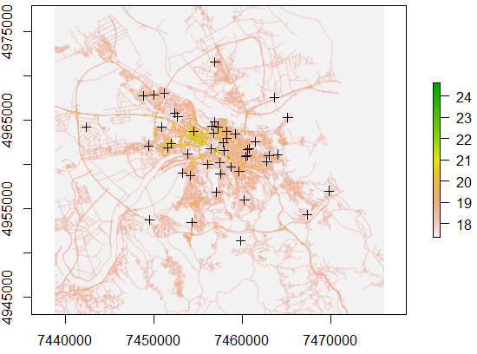(a) | 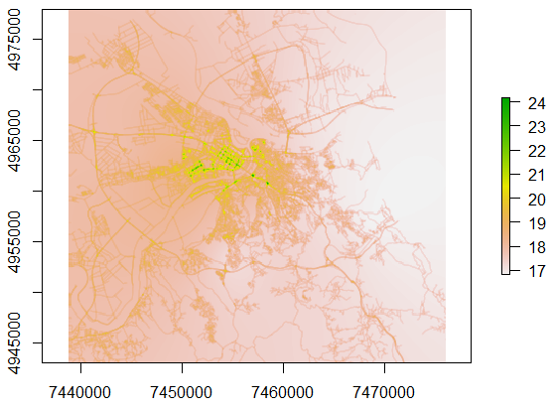(b)
Figure 1. a) Base map for PM_{2.5} [ug/m³] and position of 47 stations b) Fused map [ug/m³] (observations were simulated using Gaussian distribution with mean value obtained from basemap and relative standard deviation of 5%)

Also ensure that legends, labels and captions can be read clearly. Format of Tables-please use the following format in MS Word as shown below:
Table 1. Maximum hourly concentrations of air pollutants measured at three stations.
 | PM₁₀ | CO  ppm | NO;  Ppb
Station 1 | 75 | 15 | 203
Station 2 | 82 | 17 | 159
Station 3 | 51 | 13 | 131

Figures and Tables should be integrated into the text and placed appropriately.
References should be in font size 9 and arranged alphabetically. In text, refer to references as follows. If there is only one author use (Zambelli, 2015), if there are two authors use (Isaaks and Srivastava, 1989), if there are more then two authors use (Briggs et al, 1997). If you are referencing several authors at once, separate references using semicolon (Briggs et al, 2015; Johnson et al, 2010; Mueller et al, 2015). Example of list of alphabeticaly ordered references which include paper, book, software package and PhD thesis is given at the end of this document.
SUBMISSION OF ABSTRACT AND PAPER
Please submit your one page abstract, and the short paper in MS Word format, using Papers Submission Form at http://www.vin.bg.ac.rs/webiopatr/#Workshop/Papers-submission. Papers submission timings should be in line with time table outlined at http://www.vin.bg.ac.rs/webiopatr/#Workshop/Key-dates-and-deadlines
REFERENCES
- Briggs, D. J., Collins, S., Elliott, P., Fischer, P., Kingham, S., Lebret, E. et al, 1997. Mapping urban air pollution using GIS: a regression-based approach, International Journal of Geographical Information Science 11, 699-718.
- Isaaks, E. H. and Srivastava, R. M. 1989. An introduction to applied geostatistics. Oxford University Press.
- Kitanidis, P. 1997. Introduction to geostatistics: applications in hydrogeology. Cambridge University Press.
- Lahoz, W. A. and Schneider, P. 2014. Data assimilation: making sense of Earth Observation, Frontiers in Environmental Science 2, 16.1-16.28.
- R Development Core Team, 2013. R: A language and environment for statistical computing. Vienna, Austria: R Foundation for Statistical Computing; http://www.r-project.org, (access Decembar 2015.)
- Zambelli, P. 2015. A spatial decision support system to assess personal exposure to air pollution integrating sensor measurements, PhD thesis, University of Trento

